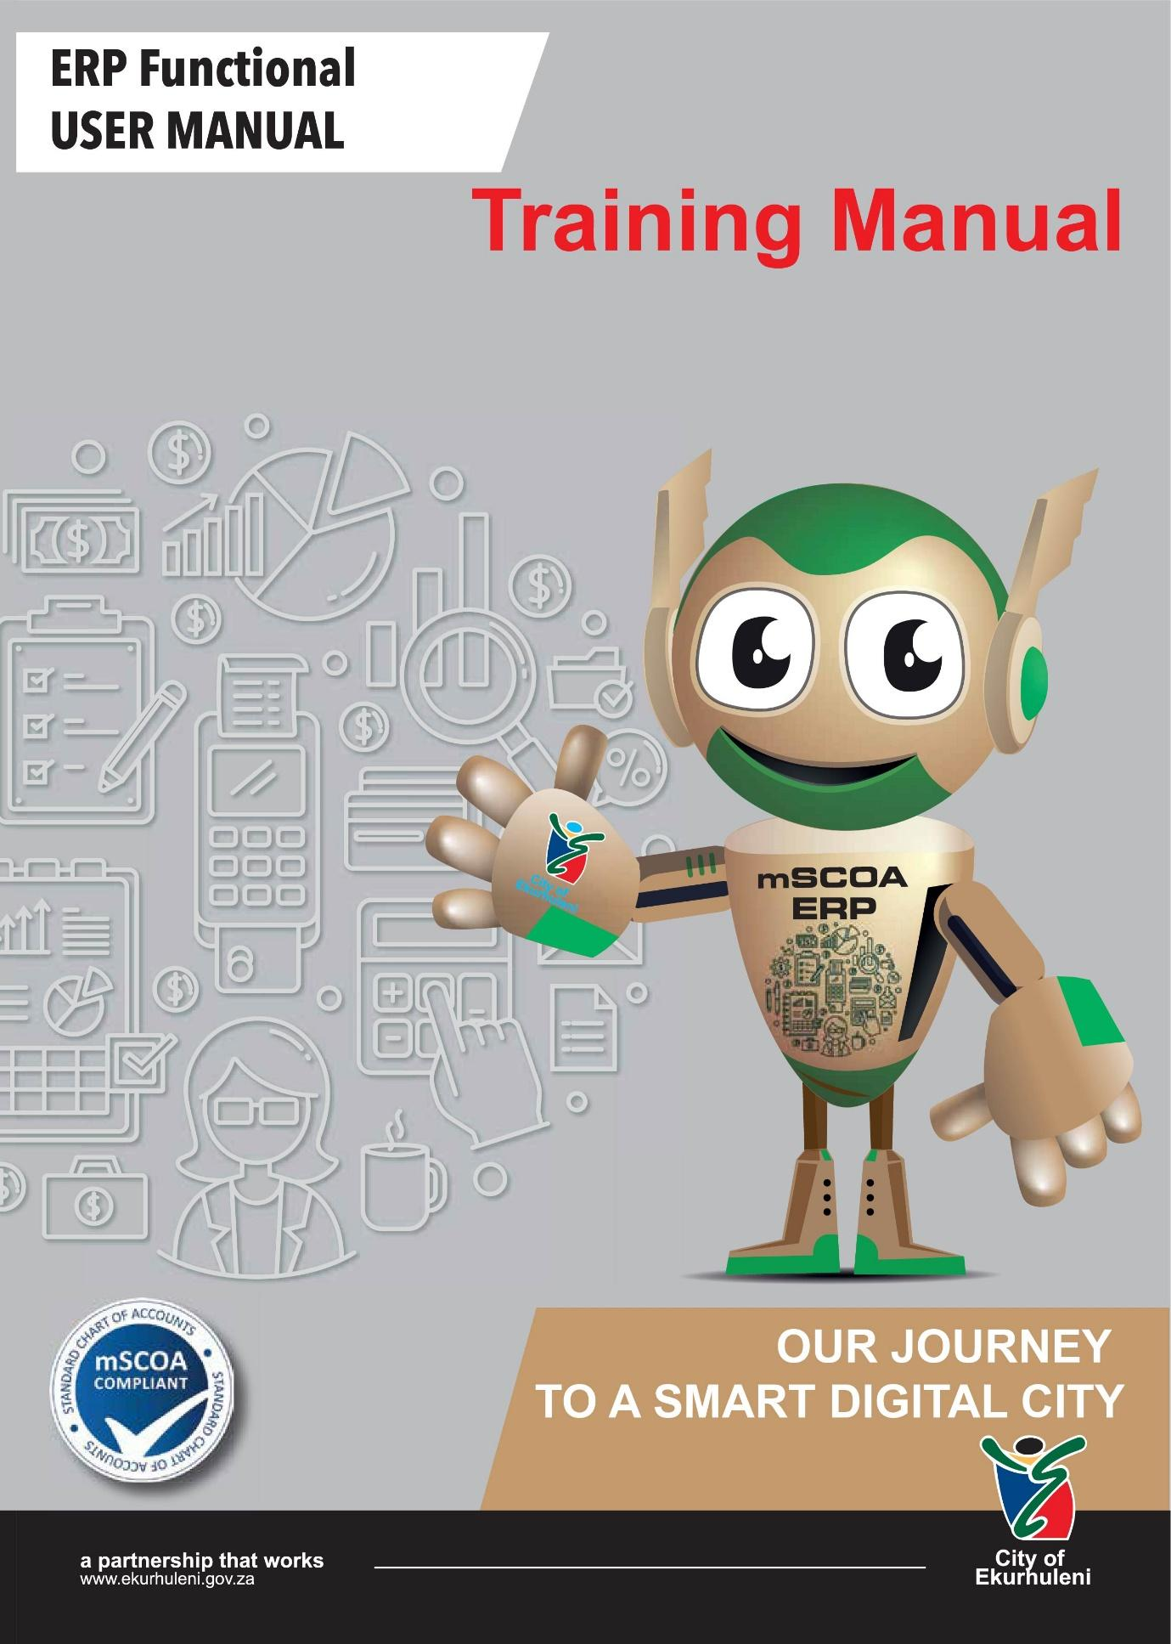

Incident Management System (IMS) Customer

TABLE OF CONTENTS

1 OVERVIEW 2
● 1.1 INTRODUCTION 2
● 1.2 mSCOA ERP 4
2 GENERAL SYSTEM INFORMATION 5
3 LEARNING REQUIREMENTS 6
4 LEARNING EXPECTATIONS 6
5 LEARNING JOURNEY 7
6 KEY AREAS OF LEARNING 8
7 LEARNING OUTCOMES 8
8 KEY ICONS WITHIN THE LEARNING MATERIAL 9
9 REGISTERING ON IMS 10
10 FORGOT PASSWORD 17
11 LOGIN TO IMS 19
12 NAVIGATING THE DASHBOARD 20
13 MY ACCOUNT – UPDATING YOUR PROFILE 22
14 MY ACCOUNT – UPDATE PASSWORD 26
15 CAPTURE A NEW INCIDENT 28
16 MY INCIDENT QUEUE – VIEWING A CASE 34
17 RESOLVED INCIDENTS 38
18 LOGIN HISTORY 39
19 HELPFUL HINTS 41
20 ASSESSMENTS OF SPECIFIC LEARNING OUTCOMES 42
21 NEXT STEPS 42

OVERVIEW

1.1 INTRODUCTION
City of Ekurhuleni (COE) has a mandate to promote the Smart City concept for transformation, growth, development and ensure that all Ekurhuleni’s citizens derive sustainable benefit from technology development. The Information and Communication Technology (ICT) department has a responsibility to ensure that ICT goals are aligned to and support the City’s mission and strategic objectives of becoming and Smart, Creative and Developmental City, and that optimum business value is realized from ICT related investment services and assets. Information and Communication Technology (ICT) is one of the key strategic enabling department within the City. It uses and leverage on the implementation of technology to enable the City to deliver services effectively and efficiently.
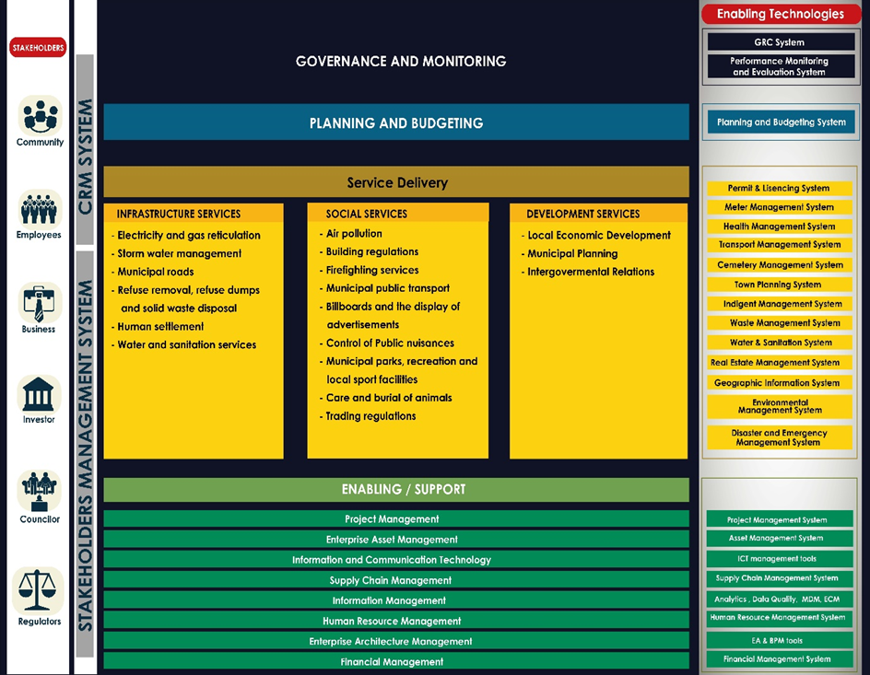Figure 1: City Model
The municipal reference model has been set as a standard capability reference for all the departments. It illustrates the core, enabling/ support functions and its relevant systems, and the different stakeholders involved.
Governance and Monitoring is an overarching capability providing an oversight to all capabilities in the municipality.
Strategy capability is responsible for all planning and budget related capability for the CoE municipality. Evaluating existing business unit strategy based on the company's strategy and eliminate unwanted/unnecessary resources/elements and re-consider necessary resources to meet the overall company's strategy.
Core capability is all the municipality business processes mandated by the municipal act, to provide all constitutionally mandated services as prescribed by the Section 4 B and Schedule 5 Part B of the constitution.
Enabling/Supporting capability is all the transversal function within the municipality, that provide support to core process with a view to deliver the municipal mandated services.
Enabling Technology is all the systems/ applications used by the municipality to support internal business process, each capability layer will comprise associated applications.

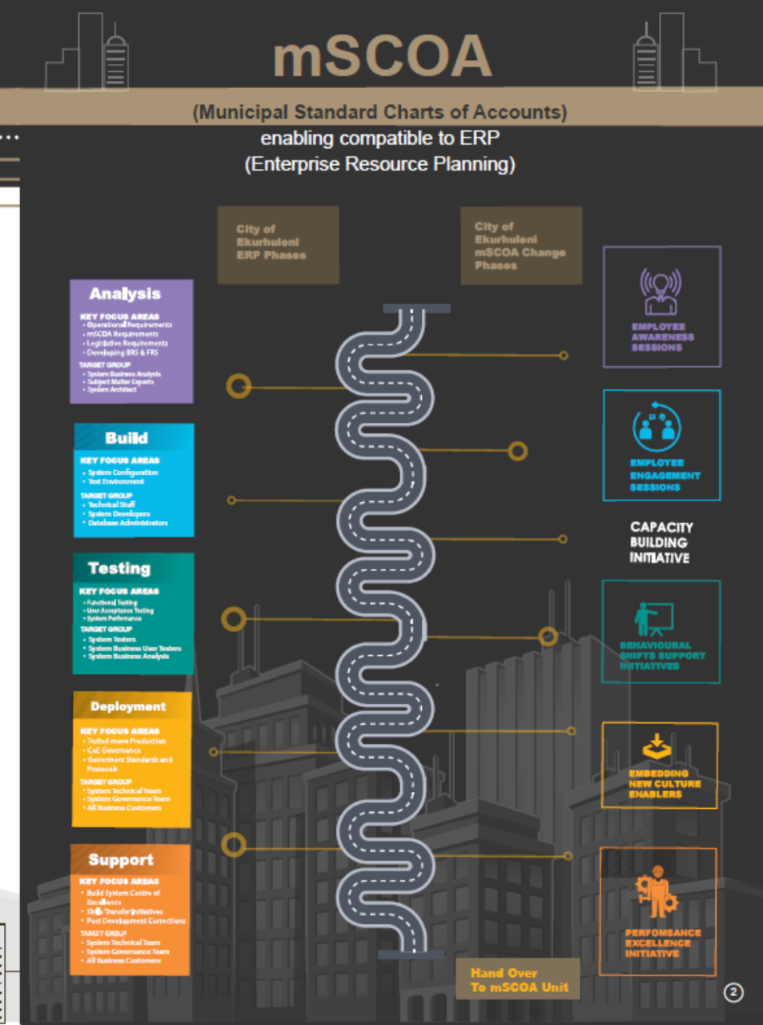
1.2 mSCOA ERP

GENERAL SYSTEM INFORMATION

The Incident Management module is a back office department solution where cases will be managed from the time a service is requested / incident or case logged to when it is closed or solved. The service will be delivered according to the service level agreement. A more efficient way to communicate with customers is enabled from this type of design. Automated notifications can be status driven across all applications, ensuring that customers are kept informed via e-mail and SMS as changes to their requests are updated. Feedback to customers is system automated to ensure the customer is always informed of change. This in turn reduces the workload on service staff and allows attention to be focused to high prioritized tasks.

LEARNING REQUIREMENTS

It is expected that learners have the following pre-requisites:
- Computer literacy
- A good understanding of the Incident Management System (IMS).

This User Guide is intended for the following audience:

- Customer

LEARNING EXPECTATIONS
Understand System Concepts:
- System Registration
- System Login
- Updating Profile
- Log an Incident.
- Upload Images

LEARNING JOURNEY
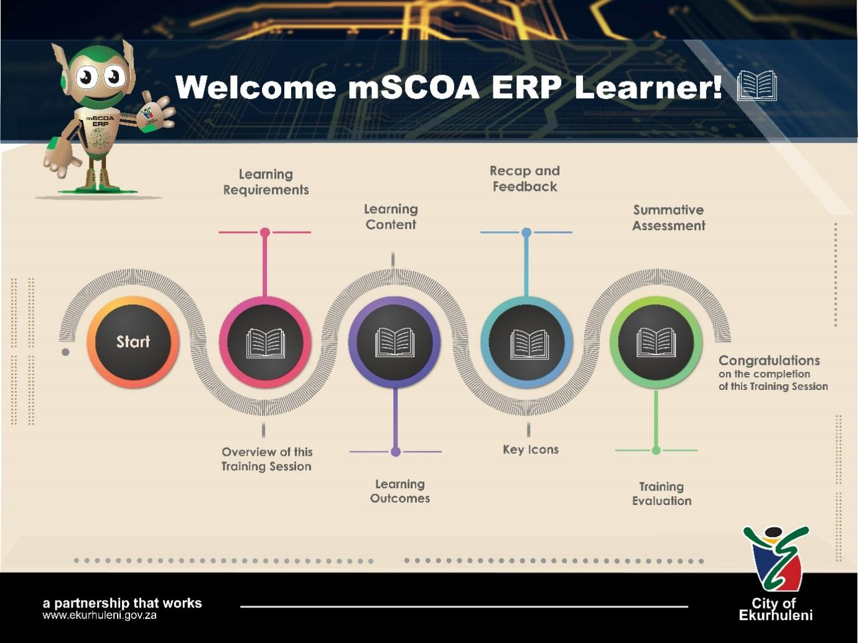

KEY AREAS OF LEARNING

1 | REGISTERING ON IMS
2 | FORGOT PASSWORD
3 | LOGIN TO IMS
4 | NAVIGATING THE DASHBOARD
5 | MY ACCOUNT – UPDATING YOUR PROFILE
6 | MY ACCOUNT – UPDATE PASSWORD
7 | CAPTURING A NEW INCIDENT
8 | MY INCIDENT QUEUE – VIEWING A CASE
9 | RESOLVED INCIDENTS
10 | LOGIN HISTORY

LEARNING OUTCOMES

At the end of this module, you will be able to:
- Navigate the Incident Management System (IMS).
- Log an Incident/ Service request
- View cases and documents

KEY ICONS WITHIN THE LEARNING MATERIAL

Note
Activity
Information
Learning Outcomes

REGISTERING ON IMS
After completing this sub-section, you will be able to register on the Incident Management System.
The process begins when the customer opens the Google chrome web browser and browse the following link in the browser search pane; https://10.1.2.126/CMSIM, where they will be navigated to the City of Ekurhuleni Incident Management System landing page.
To access IMS, you will be on the Landing Page, which is broken down into two parts:
- The Left Panel – The user can navigate through the system by:
- Login
- Register
- Help

- The Right Panel – An overview of the relevant section, you have selected from the navigation panel.
Screen
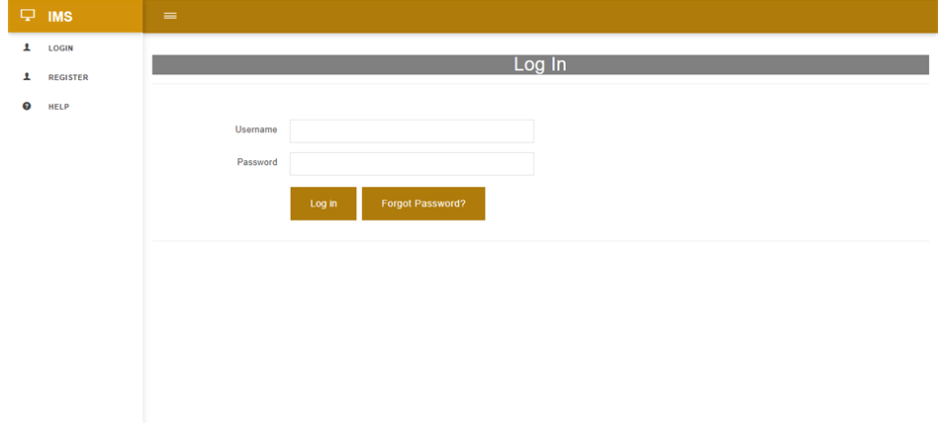
Landing Page – Log In

Navigate
On this screen:
- Click on Register tab on the left navigation panel.
- You will be re-directed to the Municipal Account Search page.
Screen
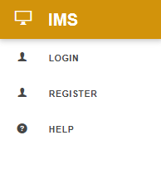

Left Navigation Panel – Before Logged In

Navigate
On this screen:
- Should you as a customer, have a municipal account, you can enter your Municipal Account Number in the field provided.
- Click the Search button
- You will be re-directed to the Register A New Profile page and all you details that you have with Ekurhuleni Municipality will be populated, except username and password.
- If you don’t have a municipal account number, select the Click Here link and you will be re-directed to the Register A New Profile page.
Screen
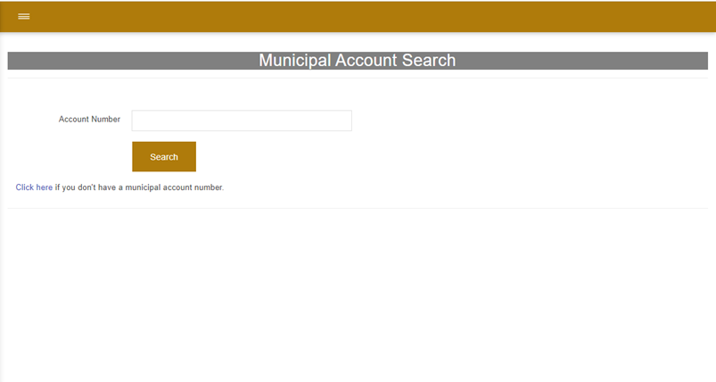

Municipal Account Search Page

- You can register without providing your ID Number, however you will not have access to Account Related Queries.
- If you have used the same Mobile Number/ Email Address/ Username previously to register, the system will not allow you to enter the same details. You are require to provide new details for these fields.
- When you have unticked the SA Citizen checkbox, the RSA Id No. field will change to Passport No. field.
Navigate
On the Registration screen:
- Mandatory fields are indicated by * next to the field label.
- You are required to capture all details, such as:
- Title – Select from dropdown list.
- South African Citizen – Untick checkbox if not a SA Citizen
- RSA Id No. / (Passport No. if Non SA Citizen)
- First Name
- Last Name
- Preferred Notification Method – Select option from dropdown menu on which you would prefer SMS/ Email or Both
- Mobile Number
- Email Address
- Username
- Password
- Confirm Password
Screen
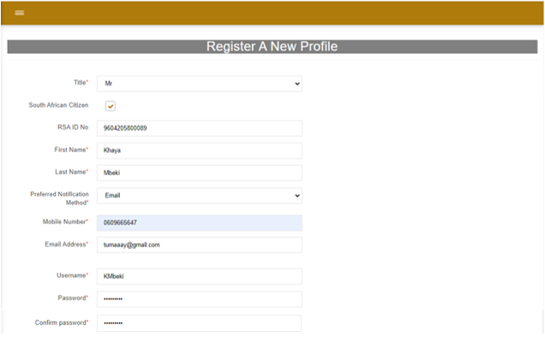
Register A New Profile Page

Non SA Citizen

- Once you have searched an address and if it falls within Ekurhuleni, it will populate the details in the fields provided.
- If your address is not within Ekurhuleni, you will receive a message that states your address falls outside of Ekurhuleni. You will have to manually capture the address details.
On this screen:
- Capture Physical Address:
- Click on the Search icon on Show Map and enter the address details.
- Select your address that is being generated and your location will be displayed on the map.
- Street Number, Street Name, City, Town and Physical Address Code fields will be autofilled after the location is displayed on the map.
- If your Postal Address is same as Physical, click Yes and the details will populate. If not, then click No and the Show Map field will displayed.
- Capture Postal Address, if it not the same as Physical Address:
- Click on the Search icon and enter the address details
- Select your address that is being generated and your location will be displayed on the map.
- Street Number, Street Name, City, Town and Physical Address Code fields will be autofilled after the location is selected on the map.
- Tick checkbox I Accept, to confirm that you accept our data privacy statement.
- Once I Accept checkbox is ticked, then only will you be able to click the Create Profile button, to proceed.
Screen
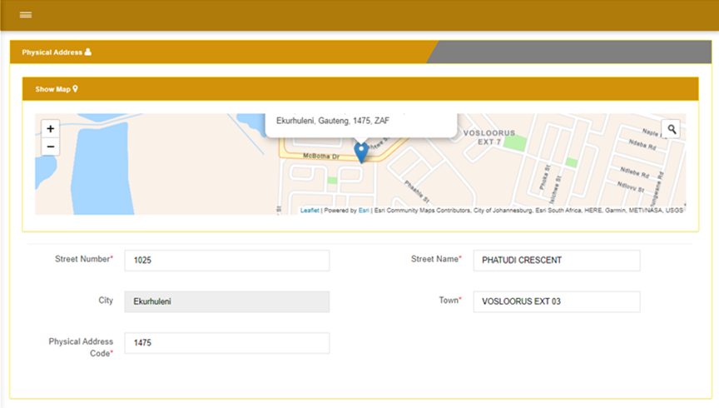

Registration – Physical Address

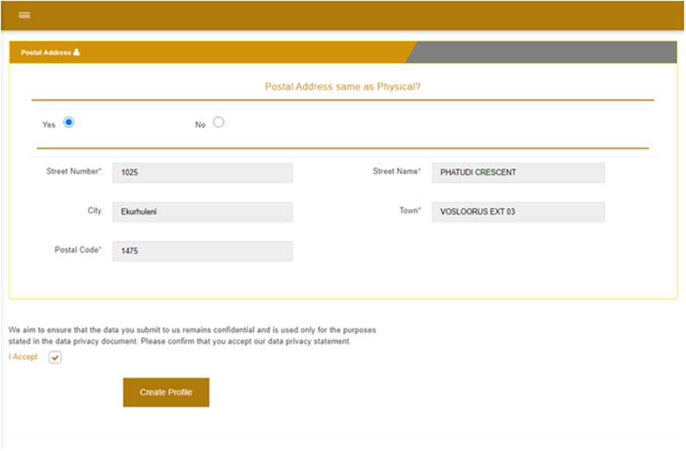

Registration – Postal Address

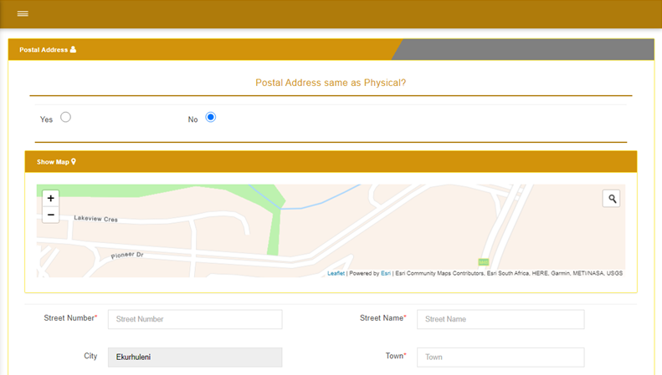

Registration – Postal Address is not the same as Physical

Navigate
On this screen:
- A popup confirmation will display Confirming will create your profile.
- Click Cancel to stop the process of creating your profile.
OR
- Click Confirm to create your profile and a notification will be displayed on the login page as Success! User Created Successfully.
- As per your preferred method of communication, an Email/ SMS/ Both will be sent to you. (In this case an email was choosen.)
Screen
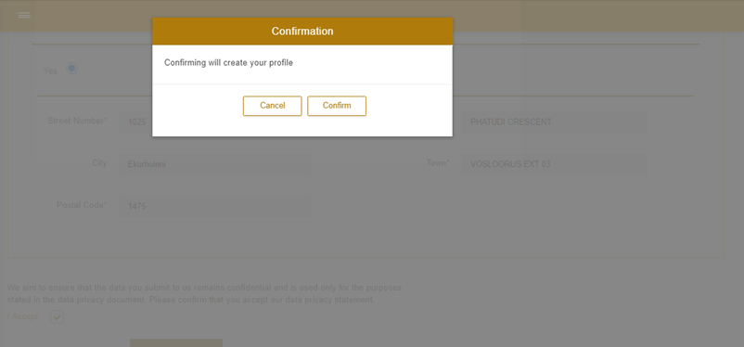

Confirmation Popup – Create your Profile

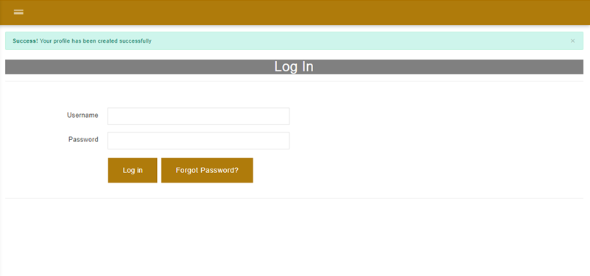

Login Page – Notification

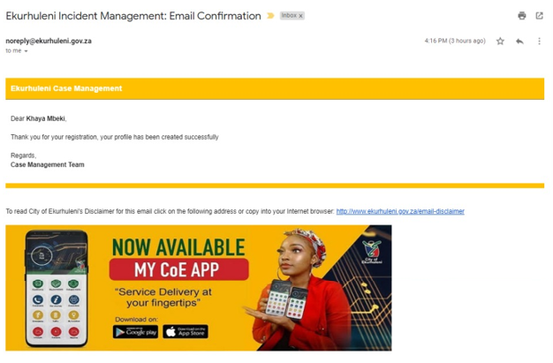
Email Notification

You have now successfully completed this sub-section

FORGOT PASSWORD
After completing this sub-section, you will be able to login to the Incident Management System.
Users should have an internet browser and internet to access the Incident Management System.
Follow the steps to reset your password to login.
Navigate
On the Log In screen:
- Click Forgot Password? Button, should you need to recover your password.
- You will be re-directed to the Forgot Password page.
Screen
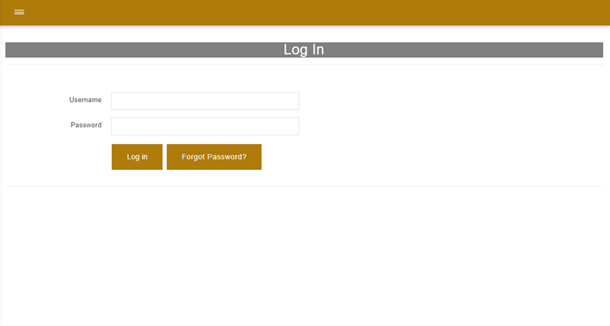

Login Page

Navigate
On this screen:
- Select between Email or Mobile Number as your Recover Method to reset your password.
- Enter the Email Address or Mobile Number you used to register with in the Email or Mobile Number text box.
- Click Reset button
- A temporary password will be sent to your Email Address or Mobile Number.
Screen
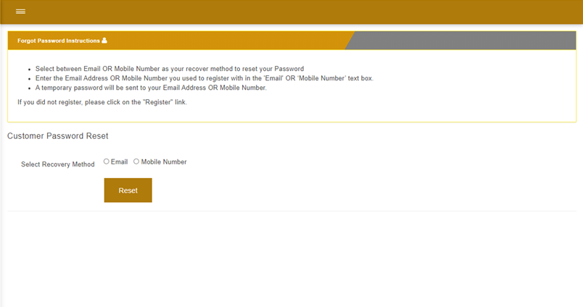

Forgot Password Page

You have now successfully completed this sub-section

LOGIN TO IMS
After completing this sub-section, you will be able to login to the Incident Management System.
Users should have an internet browser and internet to access the Incident Management System.
- User must be able to Login, in order to lodge an incident.
- Every time you log into IMS, you will receive an Email/ SMS/ Both (Based on preferred method of communication selected), to notify of that you are logged in, with the time and date.
Navigate
On the login screen:
- Enter your valid Username and Password.
- Click on the Login button
- You will be re-directed to the Dashboard.
Screen
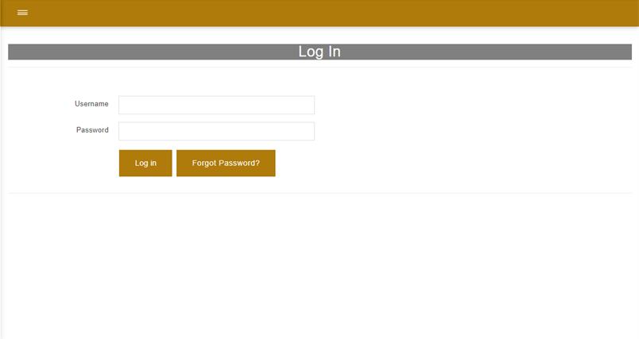

Login Page

You have now successfully completed this sub-section

NAVIGATING THE DASHBOARD
After completing this sub-section, you will be able to navigate through the Dashboard of IMS.
Process of navigating the Dashboard.
After successfully logging into the system, the Customer Dashboard will be displayed, and it is separated into two parts:
- The Left Navigation Panel will display all the queues for the customer to maneuver in the system and it is broken into six parts.
- Log Off – To exit the system.
- Home – When navigating through the system and you wish to return to the Dashboard, click on this tab.
- Help – Provides guidelines on how to complete sections within the system.
- My Account – Updating your Profile and Password.
- Incidents – Capture New Incident/ Service Request, view My Incident Queue and view Resolved Incidents.
- Login History – Gives a display of every date and time that you have logged into IMS.
- The Right Navigation Panel will display a count of the Incidents Captured, In Progress or Closed.
- Total Incidents Captured – by clicking View, you will be re-directed to My Incidents page.
- Total incidents In Progress - by clicking View, you will be re-directed to My Incidents page.
- Total Incidents Closed – by clicking on View , you will be re-directed to Re-solved Incidents page.
- Capture New Incident button, may be selected and you will be re-directed to that specific page. The Capture New Incident subheading will also reflect on the Left Navigation Panel under Incidents Tab.
Screen
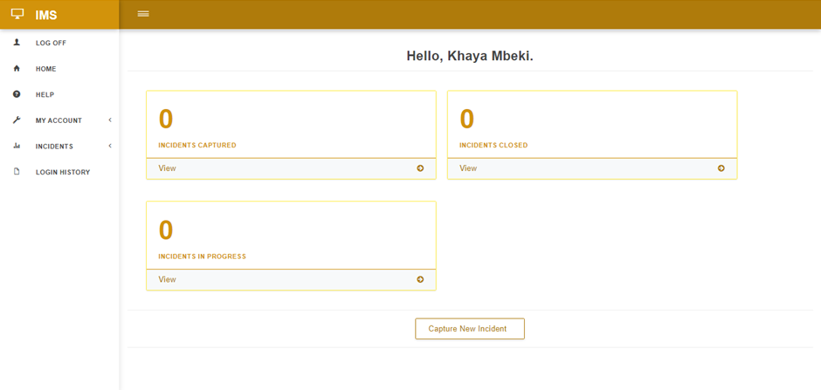
Customer Dashboard Page

You have now successfully completed this sub-section

MY ACCOUNT – UPDATING YOUR PROFILE
After completing this sub-section, you will be able to manage your account.
To manage your account, you need to update your profile.
Navigate
On this screen:
- Click My Account dropdown arrow on the left navigation panel.
- Click Update Profile
- You will be re-directed to the Register a New Profile page.
Screen
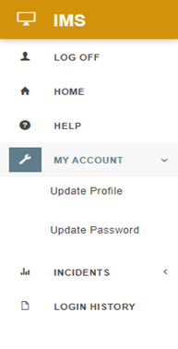

Left Navigation Panel

- Required fields are marked with a Red Asterisks *
- All sub-headings are collapsible.
- All fields are autofilled from the information inputted on the registration page.
- You are able to make changes to all fields, except for Username.
- Once you have searched an address and if it falls within Ekurhuleni, it will populate the details in the fields provided.
- If your address is not within Ekurhuleni, you will receive a message that states your address falls outside of Ekurhuleni. You will have to manually input the address details in the fields provided.
Navigate
On the Update Your Profile screen:
- You will be able to update the following:
- Title
- RSA Id No./ Passport No.
- First Name
- Last Name
- Preferred Notification Method
- Mobile Number
- Home Number
- Work Number
- Email Address
- Update Physical Address:
- Click on Show Map to expand the field
- Click on the Search icon on Show Map and enter the address details.
- Select your address that is being generated and your location will be displayed on the map.
- Street Number, Street Name, City, Town, Physical Address Code and Longitude-Latitude fields will be autofilled after the location is displayed on the map.
- Update Postal Address:
- Tick checkbox “Same as Physical” and all fields will be autofilled.
OR
- Untick checkbox and click on Show Map to expand the field.
- Click on the Search icon on Show Map and enter the address details.
- Select your address that is being generated and your location will be displayed on the map.
- Search Address on the map and select location.
- Street Number, Street Name, City, Town, Physical Address Code and Longitude-Latitude fields will be autofilled after the location is displayed on the map.
- Click the Update Profile button to save the changes.
- You will be re-directed to the Dashboard.
- A notification will display Profile Updated Successfully!
Screen
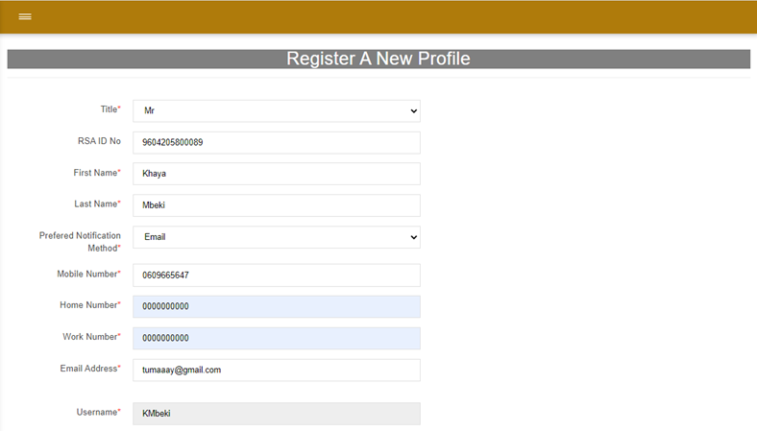
Update Profile

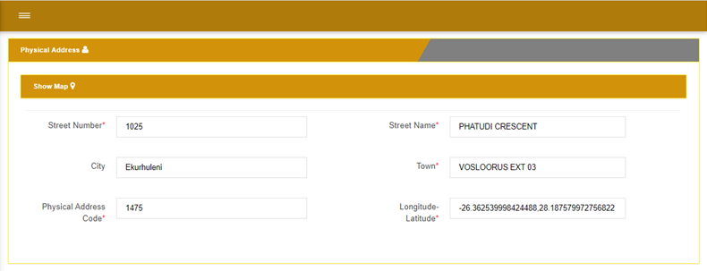

Update Profile – Physical Address

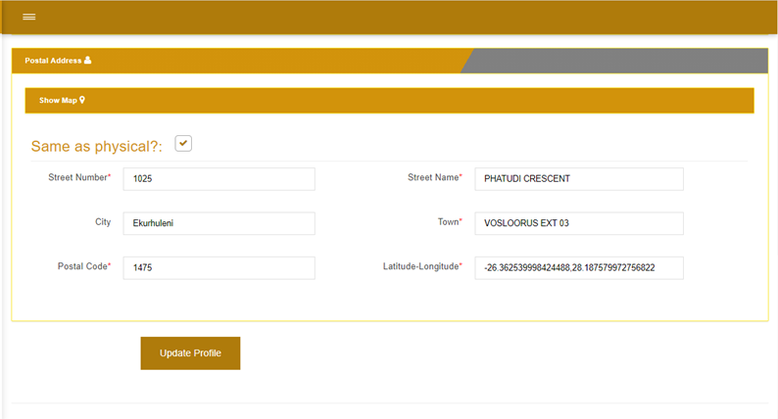

Update Profile – Postal Address

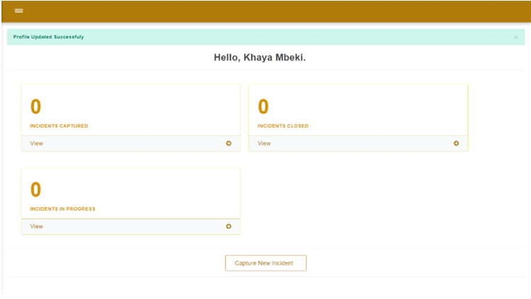

Dashboard – Notification

You have now successfully completed this sub-section

MY ACCOUNT – UPDATE PASSWORD
After completing this sub-section, you will be able to update your password on Incident Management System.
The customer can update/ edit their password at any stage.
Navigate
On this screen:
- Click My Account dropdown arrow on the left navigation panel.
- Click Update Password
- You will be re-directed to the Change Password page.
Screen

Left Navigation Panel

Navigate
On this screen:
- Enter the following:
- Current Password
- New Password
- Confirm New Password
- Click on Change Password button
- You will be re-directed to the Dashboard.
- A notification will display Password has been reset!
Screen
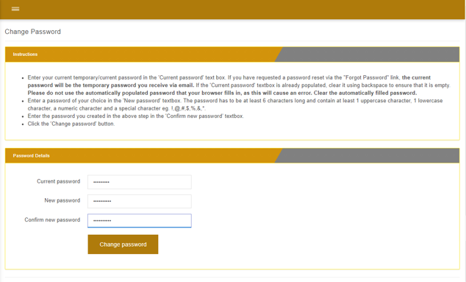

Change Password Page

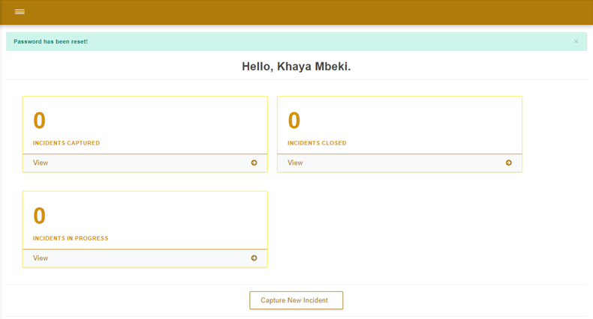

Dashboard - Notification

You have now successfully completed this sub-section

CAPTURE A NEW INCIDENT
After completing this sub-section, you will be able to capture a new incident on IMS.
Process of the customer capturing a new incident/ service request.
Navigate
On this screen:
- Click Incidents dropdown arrow on the left navigation panel.
- Click Capture New Incident
- You will be re-directed to the Capture New Incident page.
Screen
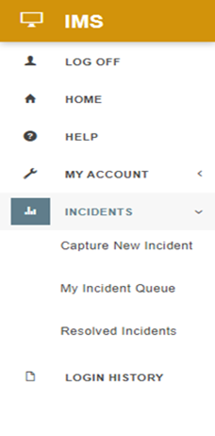

Left Navigation Panel

- Required fields are marked with a Red Asterisks *
- All sub-headings are collapsible.
Navigate
On this screen:
- By clicking on Capture Incident Help tab, the tab will expand with helpful guidelines on how to complete the Service Failure Section.
- Searching the table by Fault Code/ Service Failure/ Department filters the table.
- Department and Incident fields will be populated by clicking the service details you wish to select.
- Service Details can be changed by clicking on any other service details you wish to select.
- Click on Priority dropdown, make a selection based on the importance of the incident/ service request. E.g., High
- Click on Region and Area dropdown list and make a selection.
Screen
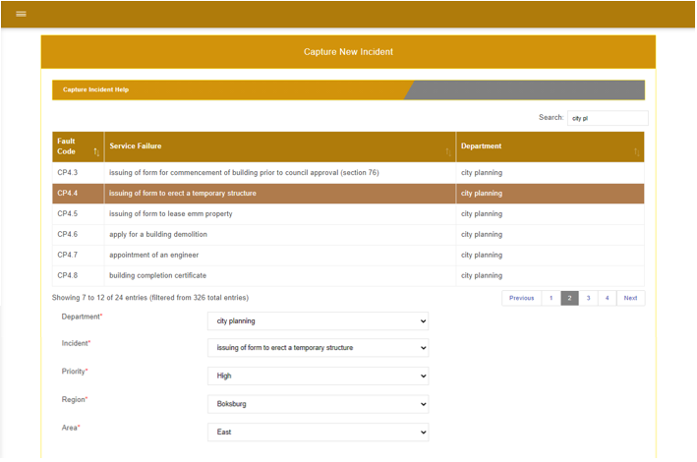
Capture New Incident

Navigate
On this screen:
- Select Use my Physical Address and all Case Address fields will be populated.
OR
- Select Use Incident Address and the Show Map field will expand.
- Click on the Search icon on Show Map and enter the address details.
- Select your address that is being generated and your location will be displayed on the map.
- Street Number, Street Name, City, Town, Physical Address Code and Longitude-Latitude fields will be autofilled after the location is displayed on the map.
Screen
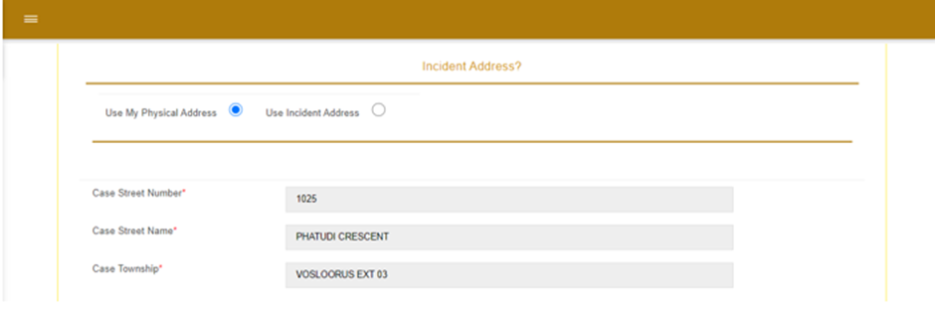

Capture New Incident – Use My Physical Address

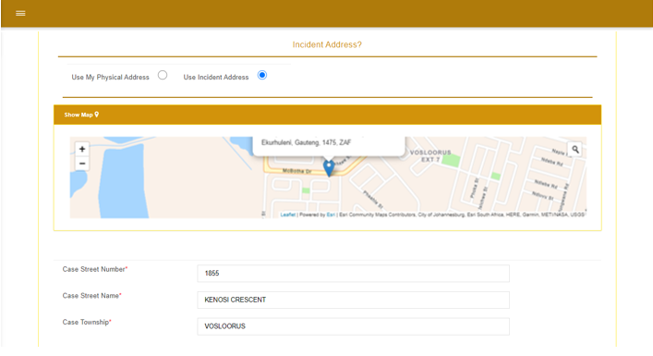

Capture New Incident – Use Incident Address

Valid file types for uploading images are:
- Jpg
- Png
- Jpeg
Navigate
On this screen:
- It is optional, should you wish to capture the Incident Description in the text box provide.
- Upload the Incident Image by clicking on Choose Files and the image will be displayed. Click Remove button to remove the image.
- Proceed to click the Submit button, if all the information is correct and you wish to proceed to log this incident/ service request.
- Back to Top button will return you to the top of the page.
- Click Reset Service Details button, should you wish to clear all service details fields.
- Cancel button will not save all details, and a Reference number will not generated.
Screen
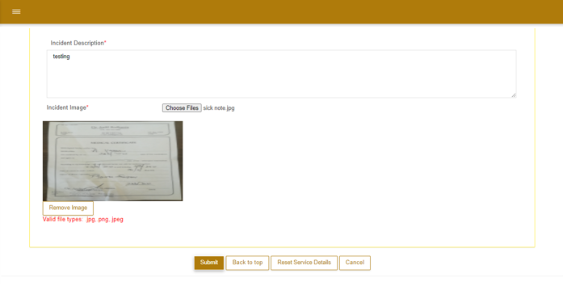

Navigate
On this screen:
- A popup Attention box will be displayed, requesting if you would like to proceed with creating this incident with the details you have provided.
- Click Cancel to stop the process of creating this incident.
OR
- Click Confirm to create this incident.
- You will be re-directed to My Open Incidents Queue page and a Notification will be displayed, informing you that the Case was created successfully with a reference number.
- An SMS/ Email or Both (depending on the customer preferred notification method) will be sent to the customer acknowledging your incident/service request, with the reference number, turnaround time and call centre contact number.
Screen
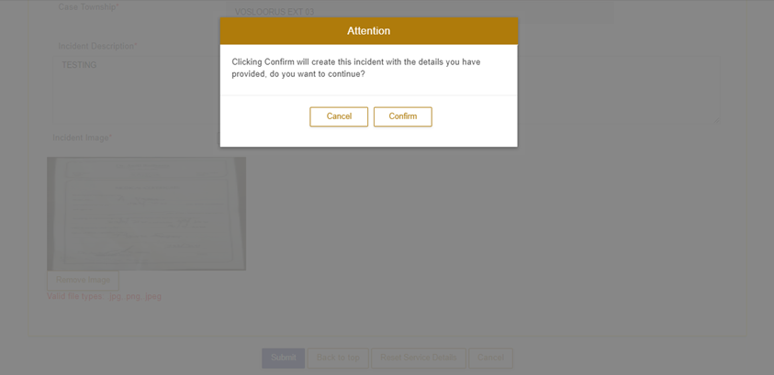

Attention Popup Box – Confirm Creating this Incident

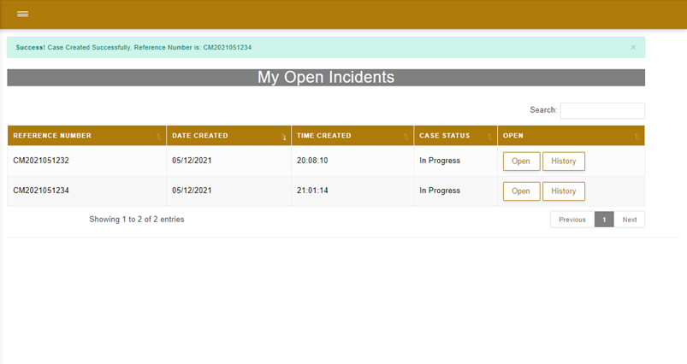

My Open Incidents Queue Page – Notification

You have now successfully completed this sub-section

MY INCIDENT QUEUE – VIEWING A CASE
After completing this sub-section, you will be able to view all case details on logged incident/ service requests under My Incident Queue page.
Navigate
On this screen:
- Click Incidents dropdown arrow on the left navigation panel.
- Click My Incident Queue
- You will be re-directed to the My Open Incidents page.
Screen
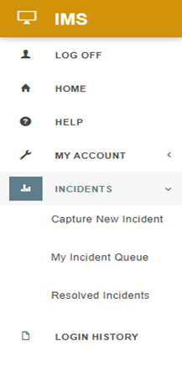

Left Navigation Panel

Navigate
On this screen:
- The table below will reflect all your incidents which you as the customer has lodged.
- You can search for a case using:
- Reference Number
- Date Created
- Time Created
- Case Status
- Click on Open button to view the case / documents.
- Click History button to view the folowing:
- Date of Action
- Status
- Comment
Screen
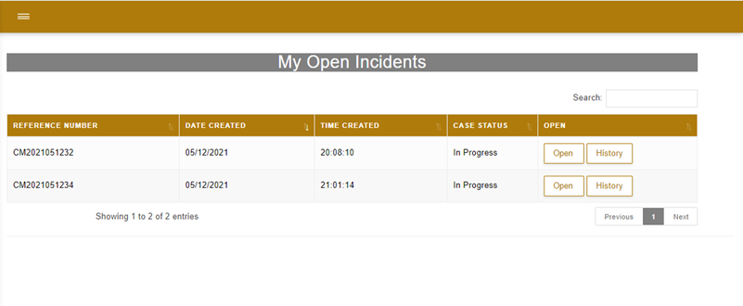

My Incident Queue Page

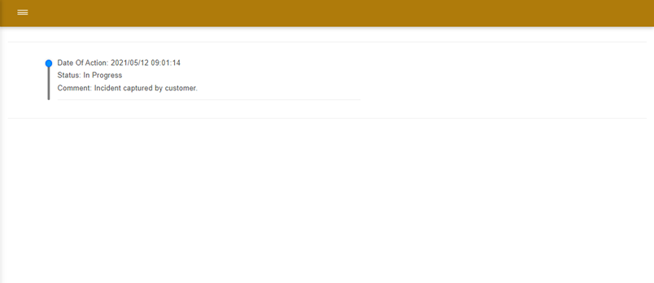
History of a Case

Navigate
After selecting the Open button, the Case screen will pop-up:
- Under the Incident Details tab, you would be able to view the following:
- Case Details
- Customer Details
- Number Of Days With Supervisor
- Number Of Days With Technician
- Number Of Days To Close Case

- Under the Incident Documents tab, you would be able to download and view the documents/ images you have uploaded when you logged the Incident/ Service Request.
- Click on the Close button to close the case on the screen.
Screen
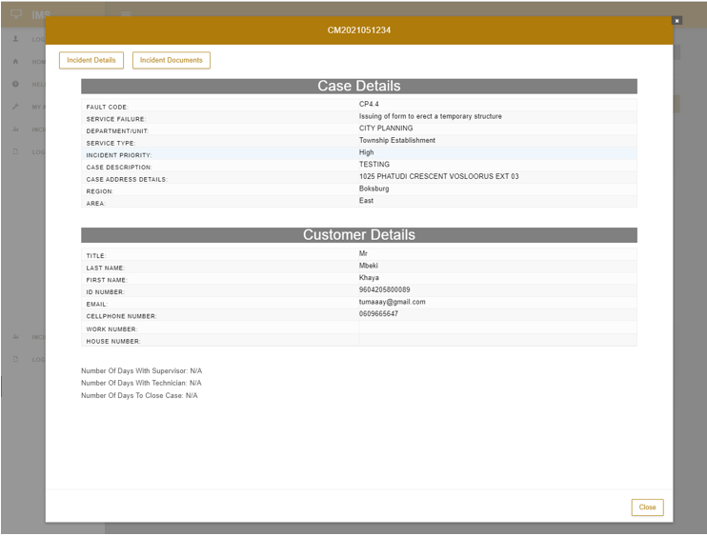

Case Details Tab

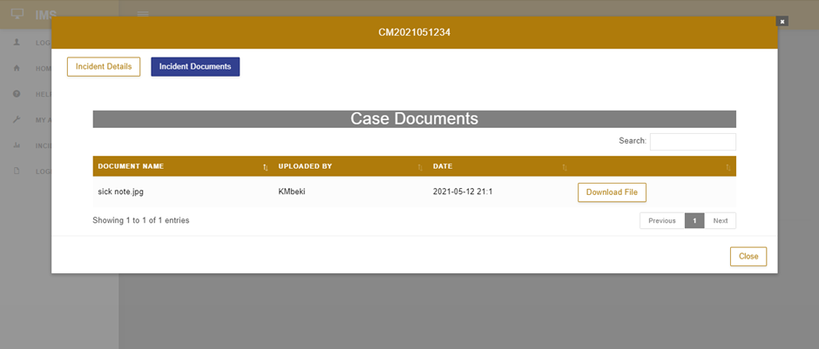

Case Documents Tab

You have now successfully completed this sub-section

RESOLVED INCIDENTS
After completing this sub-section, you will be able to view all resolved incidents.
Navigate
On this screen:
- The table below will reflect all your incidents which have been resolved.
- You can search for a case using:
- Reference Number
- Date Created
- Time Created
- Case Status
Screen
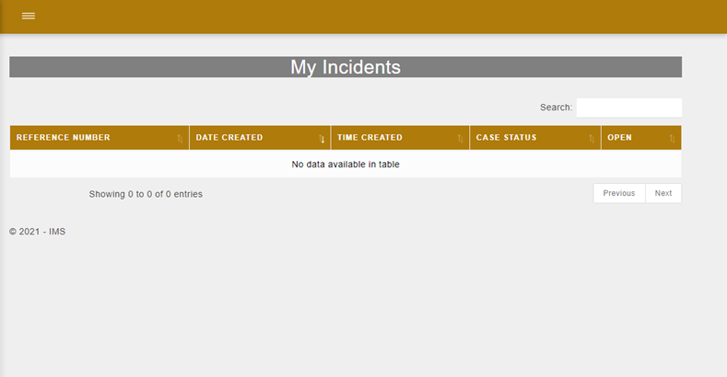
Resolved Incidents Page

You have now successfully completed this sub-section

LOGIN HISTORY
After completing this sub-section, you will be able to view login history.
Login History feature enables you to get an overview of your login trail including the time and date.
Navigate
On this screen:
- Click Login History tab, on the Left Navigation Panel
- You will be directed to the Login Logs page, whereby you can view your login history.
Screen
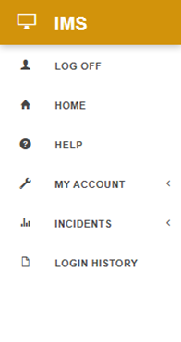

Left Navigation Panel

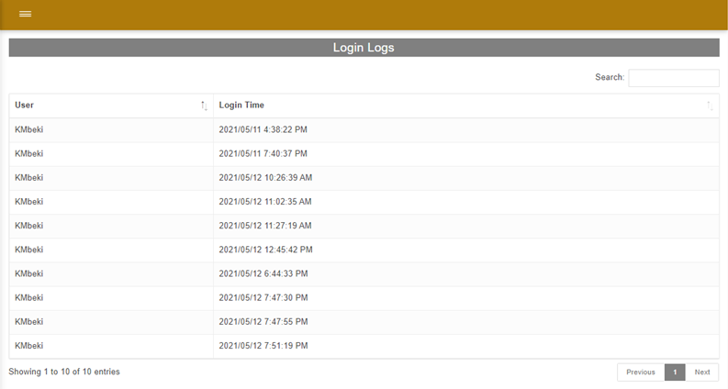
Login Logs Page

You have now successfully completed this sub-section

HELPFUL HINTS
- Be able to find useful guidelines throughout the application.
Screen | Navigate
 | To return to the Dashboard page, you can click on the IMS icon.
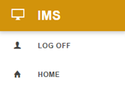 | The Home heading on the navigation panel re-directs you to the Dashboard.
 | The navigation bar allows you to expand or compress the left navigation panel.
* Red Asterisks | The Red Asterisks next to a specific field, means that it is mandatory to complete that field.
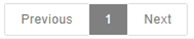 | Allows you to move to the Previous or Next page of the list in the table to view more entries.
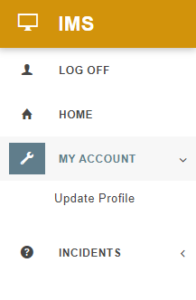 | The down or left arrow buttons next to the headings on the navigation panel allows the user to expand/ compress the sub-headings.
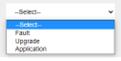 | The Select dropdown menu allows you to select an option for this field.
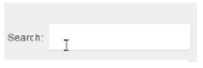 | The Search bar allows you to find what you are looking for.
 | The sorting icon allows you to move items up or down on the list.
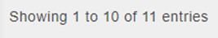 | Shows the number on entries in the table listed.
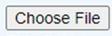 | The Choose File button allows you to search your computer to find the relevant document that you would like to upload.
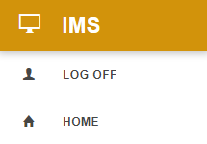 | The Log Off button, logs you off the Incident Management System and ends your session.

ASSESSMENTS OF SPECIFIC LEARNING OUTCOMES

Description of Learning Outcomes
Were you able to? | Yes  Tick | No  Tick
REGISTERING ON IMS
FORGOT PASSWORD
LOGIN TO IMS
NAVIGATING THE DASHBOARD
MY ACCOUNT – UPDATING YOUR PROFILE
MY ACCOUNT – UPDATE PASSWORD
CAPTURING A NEW INCIDENT
MY INCIDENT QUEUE – VIEWING A CASE
RESOLVED INCIDENTS
LOGIN HISTORY

NEXT STEPS

You will be required to complete the following:

 | Training Evaluation
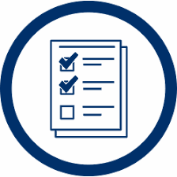 | Assessment

